


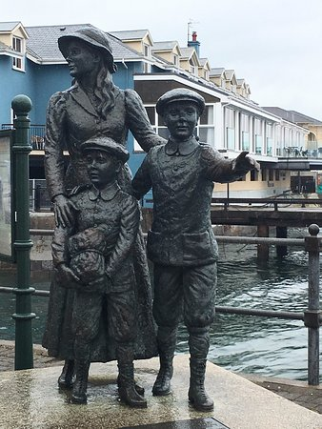

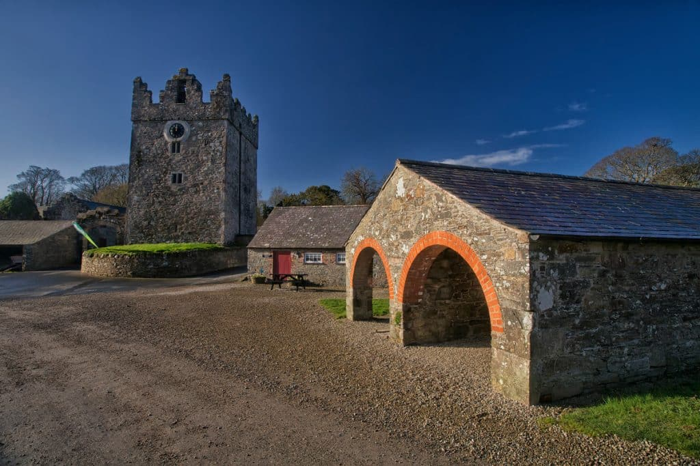
We know the irish music as the folcloric
music which survived in Ireland during
XX century. Irish music had influence
in american country music and that
genre in rock music.
Music
sculpture
Riverdance made Irish dance popular in 1994. That dance consist in moving your legs and feet really quickly while you let your body motionless.
Dance
Cobh was known as starting point for million of Irish people who emigrated to USA escaping from famine. Annie Moore was the first person who died in Great Famine, she was 15 years old.
Ireland’s history is very rich. You won’t just read it in books, you can explore, visit and touch. Crumbling castles, grand country estates and island monasteries are still standing strong today. If you like history, you will love Ireland.
History
Castles are abundant. In Antrim, the crumbling Dunluce has hosted warring Vikings and survivors of the Spanish Armada “Invencible” when it crashed.

Castles

